Congratulations to everyone who has been turning up to the Couch 2 5k sessions on a regular basis. By now many people have commented that they are seeing an improvement in their fitness levels and enjoying the group sessions. For all the participants, here are a few extra tips to help you on the way and some stretches for you to do after each session.

- Fuel your body for exercise. Try and leave 2 hours between eating a large meal and exercising. The best way is to have a small snack (Banana) to give you enough energy to exercise about 1 hour before. After your session have a meal including protein (meat, fish, and lentils) to repair your muscles.

- Wear the correct footwear. Your trainers don’t have to be designer and expensive but they do need to give you support and comfort.

- Aim to exercise 3-5 times per week to increase your aerobic lung capacity. Your sessions might include three c25k sessions and 2 walks a week. The more exercise you do the quicker you will improve. Exercise with a friend/family member to keep you motivated.

- Warm up ready to exercise. 5 minutes brisk walk to warm up your muscles and increase your body temperature and heart rate.

- Don’t worry about how fast you can run. Your speed will increase as you get fitter. Try and breathe in through your nose and out of your mouth while running.

- Stretch at the end of each session when your muscles are warm. Hold each stretch for 15 seconds each leg.

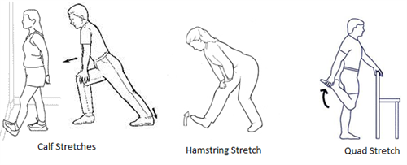
You can download the couch 2 5k app to your phone. http://www.nhs.uk/change4life/pages/couch-to-5k.aspx

